**Government Polytechnic, Awasari**



**“Department of**

**Information and Technology”**

**Project Proposal**

**On**

**“Live Auction System”**

**Submitted by**

|  |  |
| --- | --- |
| **Roll No** | **Name** |
| 22IF303 | Bangar Sarthak Nilesh |
| 22IF341 | Shinde Amit Arun |
| 22IF342 | Shinde Siddhi Tukaram |
| 22IF350 | Walse Manali Rohidas |

2022-23

Guided by

Mrs. J.G. Dabhade

1. **Rationale / Abstract:**

Online Auction management system is a web based application which will help users to buy or sell item; they can trade anything they want by posting ad. This application will allow users to post their products for auction; bidder can register and can bid for any available product. There are some existing applications that allow users for bidding but the product is not available in your local area, you cannot do inspection of the product that you are going to buy. By online Auction application user will be able to bid for product that is available in his local area.

1. **Introduction:**

Using this online auction management system, bidders will be able to get connected to the specific sellers who will offer them necessary information and or give hand to sell their items to them. It will help save time and offer quality deliverables to the bidders by quick response and attention services. This system will replace the manual way of seeking items in the market and travelling long journeys just to get an item yet there are available items just in the neighborhood.

The scope of this application to build a user friendly auctioning website, where user will be able to auctioned any product which is available nearby or anywhere in the world. By using Online Auction management system it will be easy for auctioneer to make an auction and time saving also. By making auction through this application will help to reach maximum of buyers bidding in local area.

1. **Literature Survey:**
2. Topic Selection and Literature Survey:-

We select this topic from discussion & imagination

This is a real-time project.

We visit to local politician person & discuss with guide teacher.

1. Requirement Analysis and Software Requirement Specification (SRS)
   1. At first according to our idea, we going to develop algorithm and flowchart related to our project.
   2. Take overview from existing system how to organize manually complaints from public and show it to politician. How to reply to member about solving status.
   3. According to above observation we found there are more limitation and drawback in existing system like time consuming process, limited viewer, difficult to take reports from assistance, crowded environment and unwanted participation etc.
   4. Finally we decide to implement online system for eliminate the above limitation and drawback.
   5. Then, according to that information we are going to implement web pages for registration, login form and admin and participant as well as website.
2. Discussion with Guide

We discuss our idea regarding this project with our Project guide Mrs. J.G. Dabhade mam, then guide suggest new tricks for implementing our idea for Live Auction System.

1. **Problem Statement:**

Develop an Online bidding platform for Live Auction System.

1. **Proposed Methodology:**

To develop an online auction system which will provide a forum for sellers to meet and interact with buyers, and sell items to interested bidders.

The Online auction management system shall accomplish the following as way of achieving the major goal:

To build a user friendly auctioning website, where user will be able to auction any product which is available nearby or anywhere in the world. By using Online Auction management system it will be easy for auctioneer to make an auction and time saving also. By making auction through this application will help to reach maximum of buyers bidding in local area. There will be a feature where bidder and seller can message each other. Create a panel where by a sellers receives requests from a buyer and sends back a feedback, an answer to a question or requests to meet the bidder.

To implement and test the workability of the newly developed system.

1. Enable the users to view posted products in their locality and close proximity
2. Enable creation of accounts and logging in to the accounts
3. Enable users to logout of their accounts
4. Provide interface for the administrator to view the transactions, add sellers and regions to the system.
5. The sellers should also have accounts where they will receive the customer orders and respond to them.

1. **System Design:**

* New user Registration:

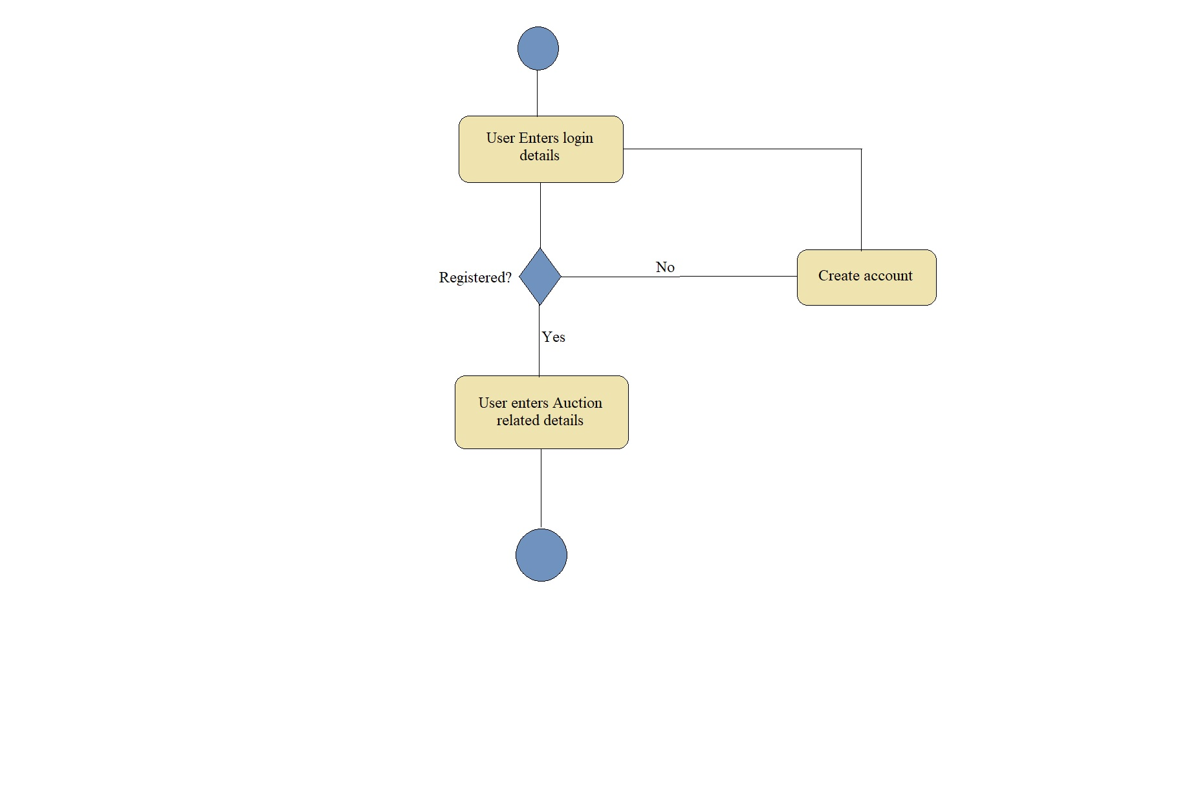

* Bidding Process:

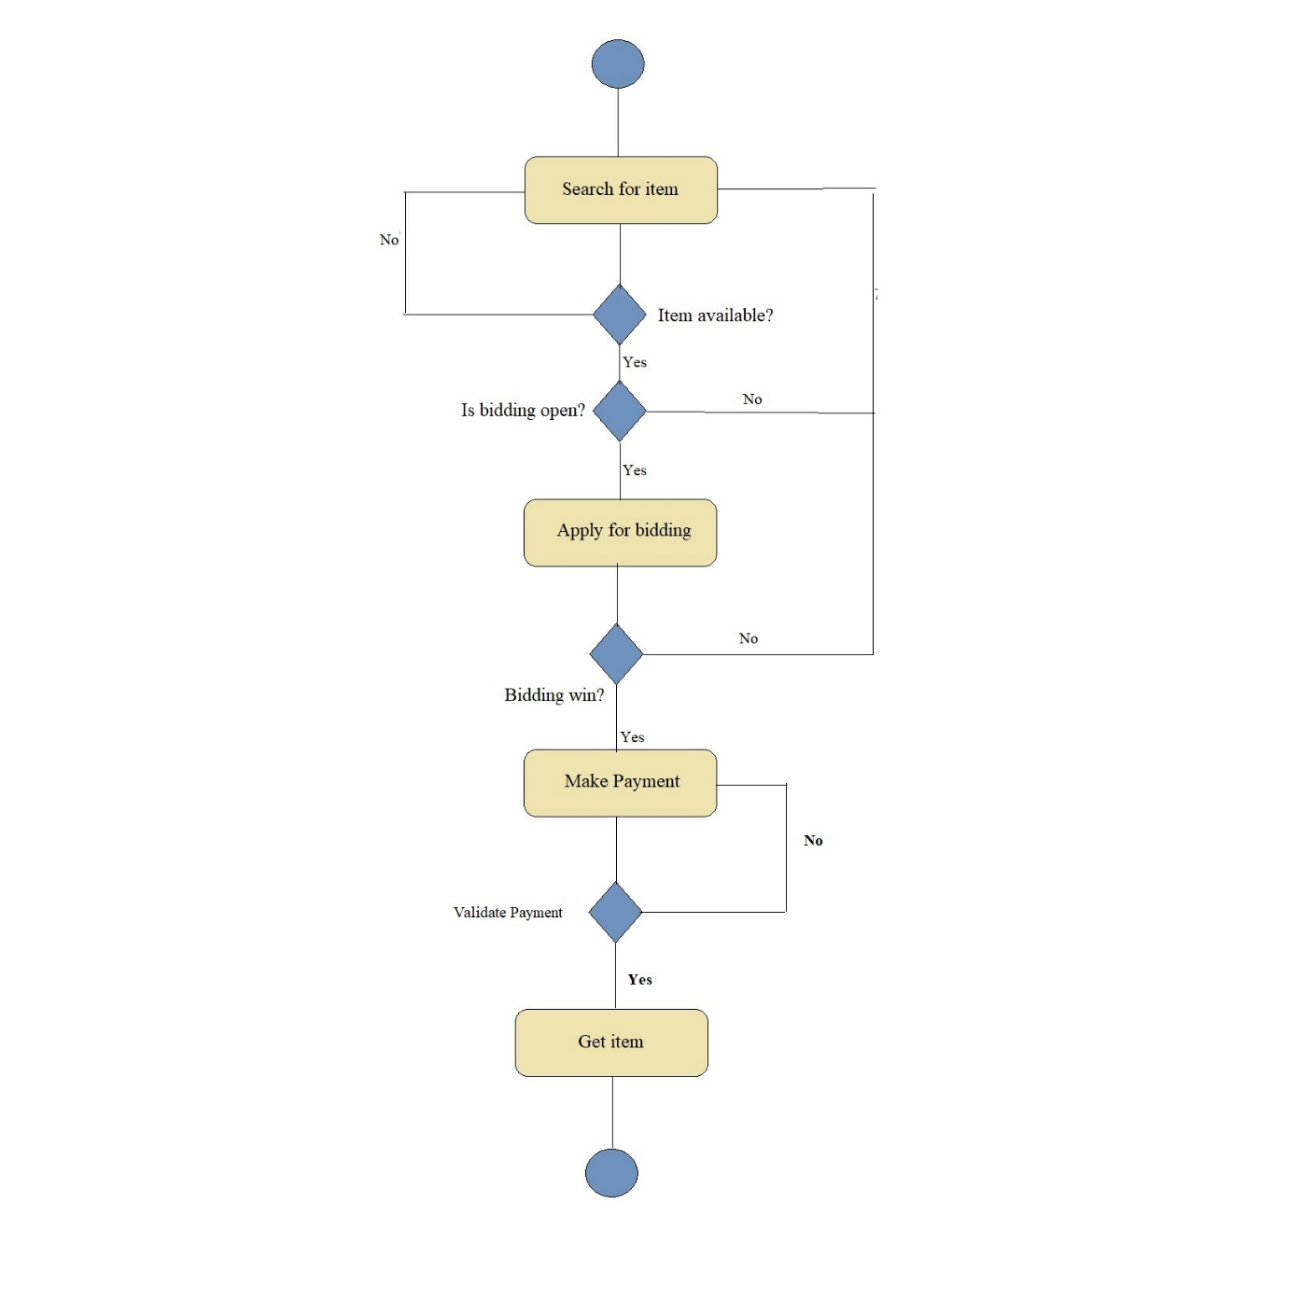

1. **Resources required:**

|  |  |  |  |  |
| --- | --- | --- | --- | --- |
| **S. No.** | **Name of Resource/material** | **Specifications** | **Qty** | **Remarks** |
|  | Web Template | Responsive web template | 1 |  |
|  | Bootstrap | Mobile Responsive Framework | 1 |  |

1. **Action / Project plan:**

|  |  |  |  |
| --- | --- | --- | --- |
| **Week No** | **Activity Planned** | **Start Date** | **End date** |
| 1 | Group Formation & Topic Selection | 22-08-2022 | 28-08-2022 |
| 2 | Topic finalization with Abstract | 29-08-2022 | 04-09-2022 |
| 3 | Finalization of Problem statement/Project title | 05-09-2022 | 11-09-2022 |
| 4 | Submission of Project proposal | 12-09-2022 | 18-09-2022 |
| 5 | requirement Gathering and analysis | 19-09-2022 | 25-09-2022 |
| 6,7 and 8 | Literature Survey | 26-09-2022 | 16-10-2022 |
| 9 | Design ER diagram DFD 0 and DFD 1 | 17-10-2022 | 06-11-2022 |
| 10 | Design Class Diagram, Use Case diagram and Deployment Diagram | 07-11-2022 | 13-10-2022 |
| 11 | Design test cases - Unit testing, Integrated Testing and system testing | 14-11-2022 | 20-10-2022 |
| 12 | Risk Identification and Costing of Project | 21-10-2022 | 27-11-2022 |
| 13 and 14 | Report Finalization | 28-11-2022 | 12-12-2022 |

1. **Names of Team Members:**

|  |  |
| --- | --- |
| **Name of the Students** | **Enrollment No.** |
| Bangar Sarthak Nilesh | 2010510345 |
| Shinde Amit Arun | 2010510390 |
| Shinde Siddhi Tukaram | 2010510391 |
| Walse Manali Rohidas | 2010510400 |

**************